Molecular Shape Reference

While Lewis dot structures can tell us how the atoms in molecules are bonded to each other, they don’t tell us the shape of the molecule. The most important thing to remember when predicting the shape of a molecule based on its chemical formula and the VSPER Theory is that the molecule will assume the shape that most minimizes electron pair repulsions. In attempting to minimize electron pair repulsions, two types of electron sets of the central atom must be considered: electrons can exist in bonding pairs, which are involved in creating a single or multiple covalent bond, or nonbonding pairs, which are pairs of electrons that are not involved in a bond, but are localized to a single atom.

The table below shows all of the commonly occurring molecular geometries that are found for molecules with four or fewer bonding domains around their central atom.

 | Electron-Domain Geometry | Bonding Domains | Nonbonding Domains | Molecular Geometry | Example
2 | 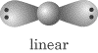 | 2 | 0 | 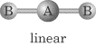
3 |  | 3 | 0 | 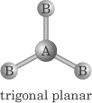 | 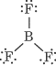
 |  | 2 | 1 | 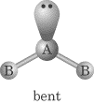 | 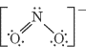
4 |  | 4 | 0 | 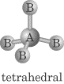 | 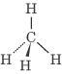
 |  | 3 | 1 | 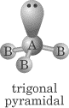 | 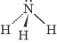
 |  | 2 | 2 | 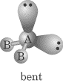 | 