Chemistry 1 Reference Sheet

D = m/v c = λν

K = °C + 273 c = Speed of light = 3.0 x 10⁸ m/s

Avogadro's number E = hν
6.022 x 10²³ particles = 1 mole
h = Planck’s constant = 6.626 x 10⁻³⁴ J·s
Error = Experimental value – Accepted value
Percent yield = actual yield x 100%
Percent Error = |Error| x 100% theoretical yield
Accepted value
Specific heat of water = 4.18 J/g·°C
M = mol of solute
L of solution Heat = mass of substance·specific heat of substance·change in temperature
H = m·c·∆T
M₁V₁ = M₂V₂

PV = nRT

Gas constant, R = 0.0821 L·atm/mol·K

Electronegativity (using the Pauling Scale)
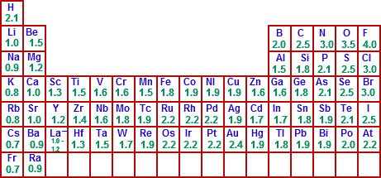

Electronegativity Difference
<0.5 | Nonpolar
0.5 – 1.7 | Polar covalent
>1.7 | Ionic

Polyatomic Ions
C₂H₃O⁻ Acetate CrO₄⁻² Chromate NO₃⁻ Nitrate
NH₄+ Ammonium ion Cr₂O₇⁻² Dichromate NO₂⁻ Nitrite
CO₃²⁻ Carbonate CN⁻ Cyanide OH⁻ Hydroxide ion
ClO⁻ Hypochlorite COOH⁻ Formate PO₄³⁻ Phosphate
ClO₂⁻ Chlorite MnO₄²⁻ Manganate PO₃³⁻ Phosphite
ClO₃⁻ Chlorate MnO₄⁻ Permanganate SO₄²⁻ Sulfate
ClO₄⁻ Perchlorate C2H4- Oxalate SO₃²⁻ Sulfite

